# Create two separate branches from master

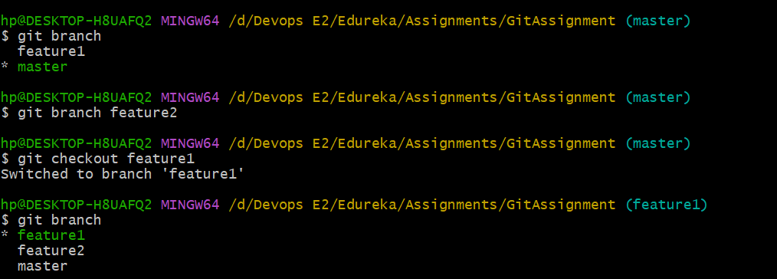

# Make changes in the same function of the source code in both the branches

Feature 1 branch change

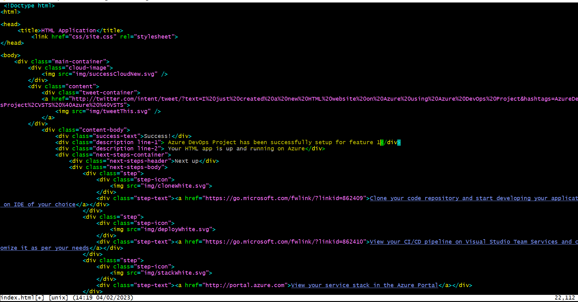

For feature2

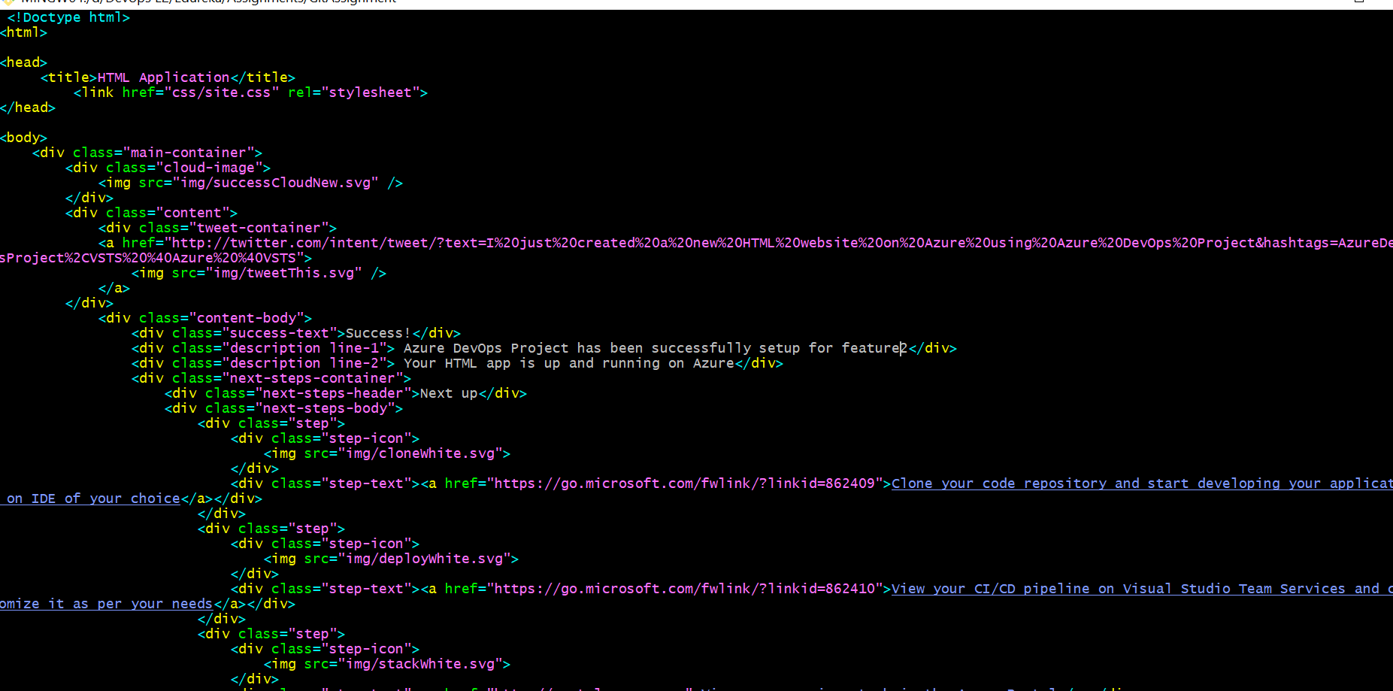

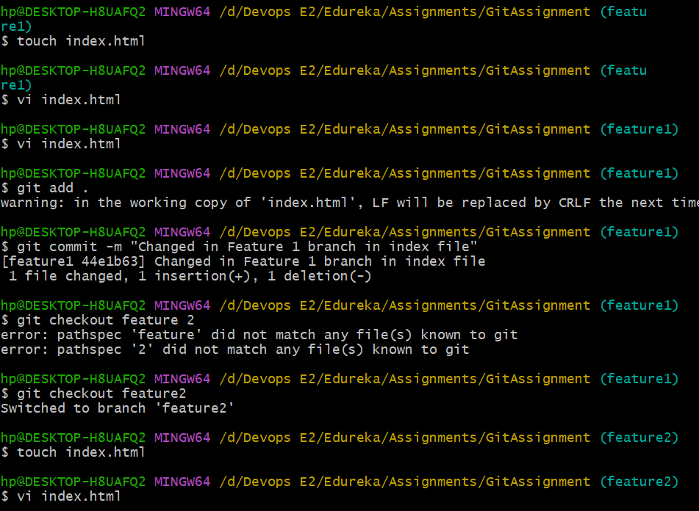

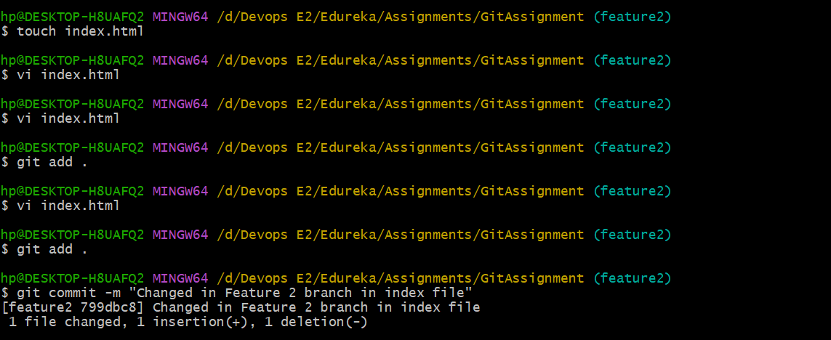

# Merge branch1 into the master



# Try and merge branch2 into the master (merge conflict should arise)



# Install a merge tool of your choice and resolve the merge conflict using git mergetool command